System Architecture, Design Specification, and Version Control for a Transmission-Gap Detection System
Anam Kazani
Department of Information Technology, University of the People
MSIT 5910-01: MSIT Capstone Project
Dr. Sirisha
September 23, 2026

Architecture Overview
The system is organized as a layered architecture with four modules stacked between the vendor data source and the monitoring nurse: an ingestion service, a gap detection and scoring engine, a queue and dashboard layer, and a disposition logging module. Walker (2022) describes the layered pattern as separating responsibilities so a change or failure in one layer does not propagate outward, and this project needs that most, since privacy and authorization controls live at specific boundaries and must remain enforceable as the rest of the system changes. Data moves in one direction through the stack — vendor records in, ranked queue out — with the disposition module feeding results back into the scoring engine's fairness monitoring rather than into the scoring path itself.
Figure 1 shows the components and their interactions: the vendor RPM platform and the enrollment record store as external sources, the ingestion service pulling from both, a transmission log datastore, the scoring engine reading from that store and writing scored records, the queue API and web dashboard reading scored records through an authorization filter, the organization's identity provider authenticating dashboard users, and the disposition store capturing outcomes.
Figure 1- System Architecture for Transmission-Gap Detection 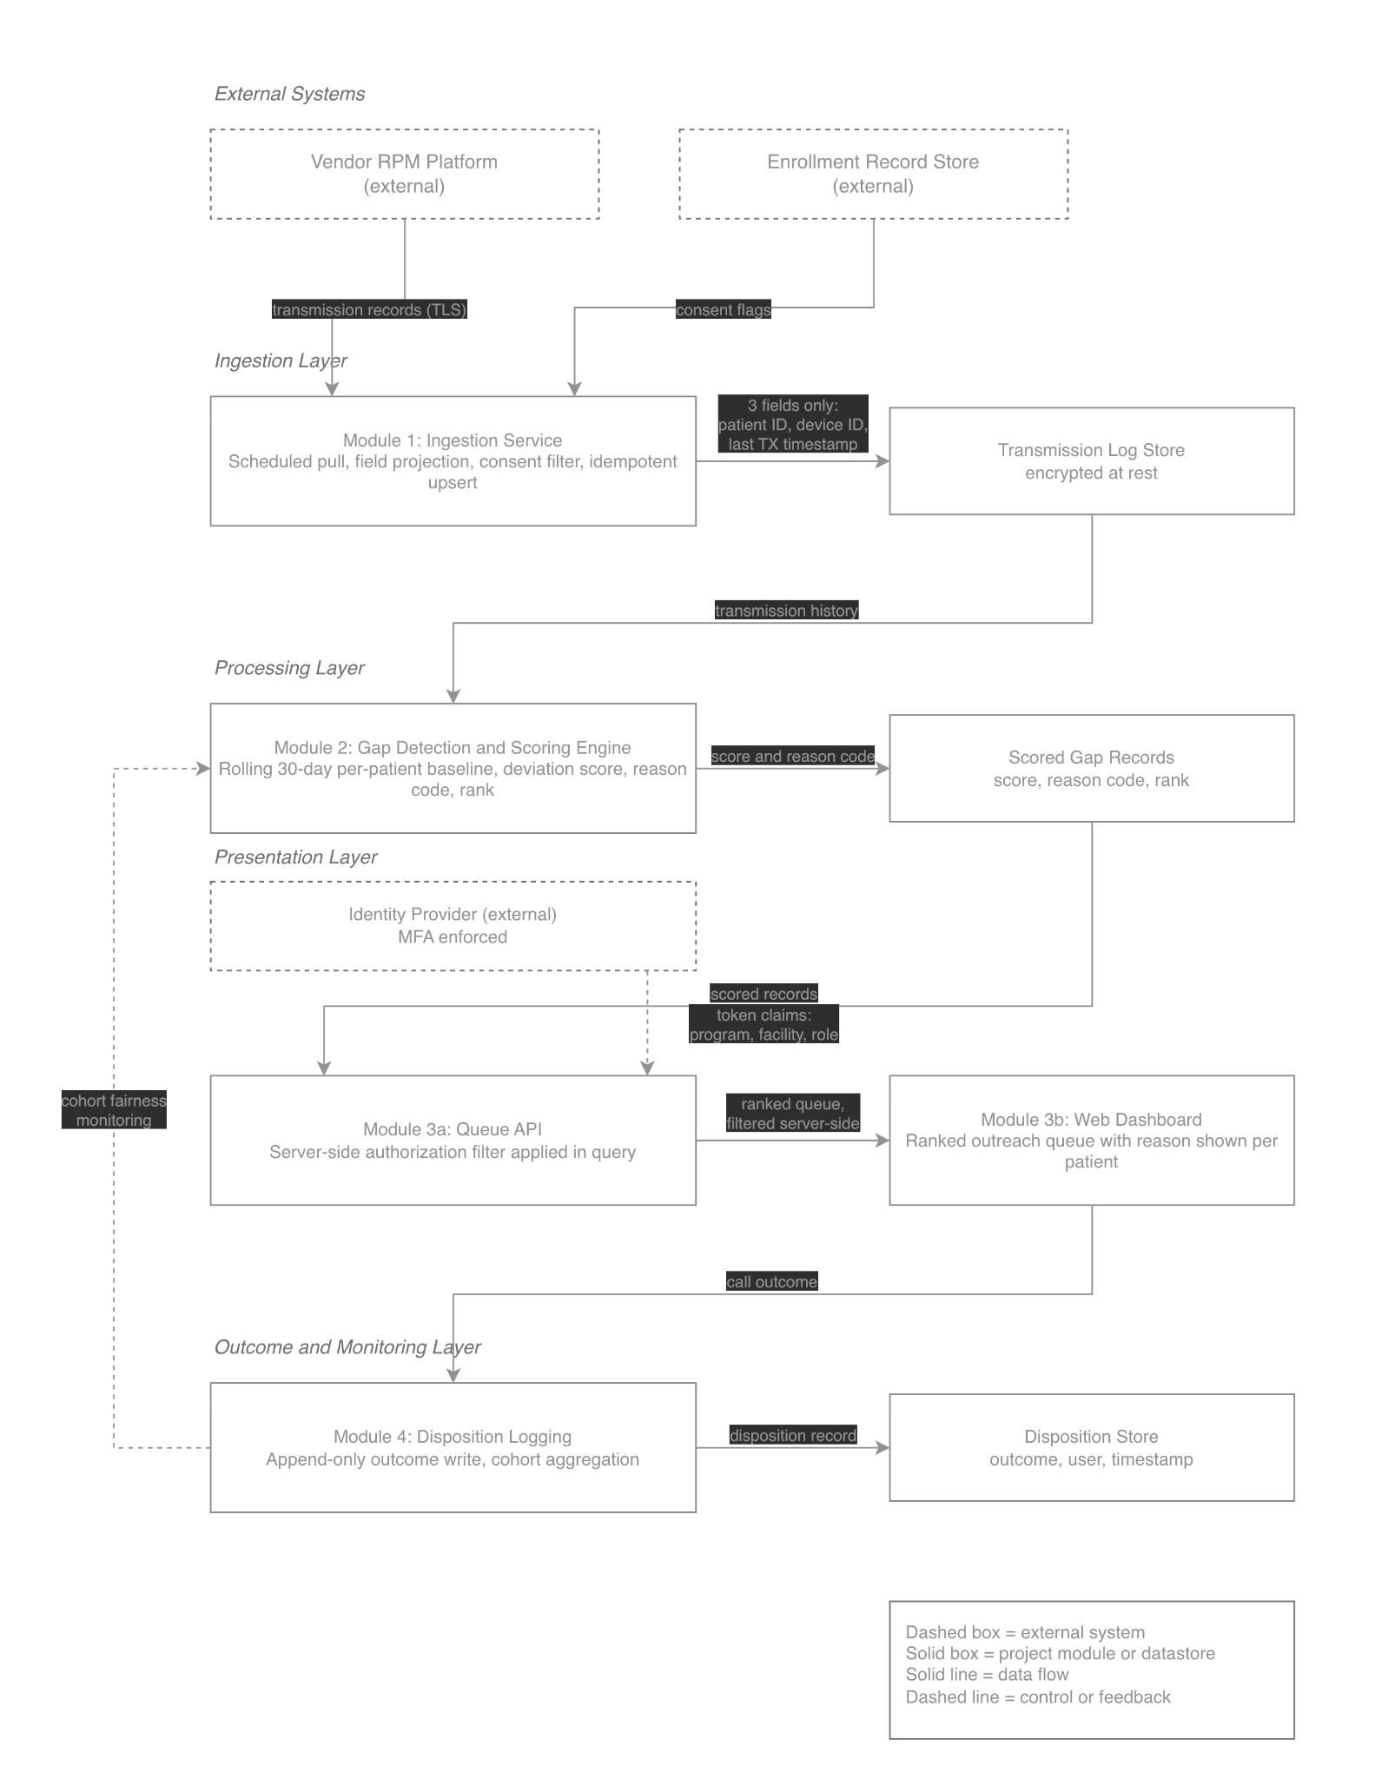
Module-Wise Breakdown
The ingestion service takes two inputs: transmission records pulled from the vendor platform on a scheduled interval, and enrollment records carrying each patient's monitoring and outreach consent flags. It outputs a set of normalized transmission events containing only a patient identifier, a device identifier, and a last-transmission timestamp. The methodology is a scheduled batch pull followed by field projection, so the vendor response is reduced to those three fields before anything is written to disk, and a consent filter that drops any patient whose flag is absent or withdrawn. Writes are idempotent upserts keyed on patient and device, so a rerun does not duplicate history. Summers (2020) argues that subsystem requirements have to be defined clearly enough that components stay coherent with the system's overall objective, and this projection is that principle expressed as an interface contract rather than as a convention the next developer may or may not follow.
The gap detection and scoring engine takes the transmission event history for each patient and device as input, and outputs a numeric gap score, a machine-readable reason code, and a ranked position. Its methodology is a rolling thirty-day per-patient baseline: the engine computes each patient's own median interval between successful transmissions, compares current elapsed silence against that personal baseline, and scores the deviation. A global threshold would be simpler, but it would misread patients whose normal transmission pattern is intermittent, so the per-patient baseline is a requirement rather than an implementation detail. Every score carries the reason that produced it.
The queue and dashboard layer takes scored gap records and an authenticated session token as input, and outputs a ranked outreach queue rendered in a web interface. The methodology is a REST API that derives the caller's program and facility assignment from token claims and applies that filter inside the query, so authorization is enforced by the service returning the data rather than by the interface displaying it. Roles distinguish monitoring nurses, who see their assigned programs, from administrators, who see aggregate counts. Authentication itself is delegated to the organization's identity provider with multi-factor enforcement.
The disposition logging module takes the outcome a nurse records after an outreach call — device failure, hospitalization, disengagement, unreachable, or resolved — and outputs a disposition record that closes the gap episode and timestamps it against the acting user. Its methodology is a simple append-only write plus a periodic aggregation that compares flag rates against confirmed-problem rates across connectivity type, age band, and geography, which is how the system's fairness is measured after deployment rather than merely asserted at design time.
Functional Requirements
FR-1: The system shall ingest transmission records from the vendor platform on a configurable schedule. FR-2: The system shall persist only the patient identifier, device identifier, and last-transmission timestamp from each record. FR-3: The system shall exclude any patient without an active monitoring and outreach consent flag. FR-4: The system shall compute a gap score for each enrolled patient relative to that patient's own thirty-day transmission baseline. FR-5: The system shall emit a reason code with every score. FR-6: The system shall present a ranked outreach queue filtered to the authenticated user's assigned programs. FR-7: The system shall record a disposition outcome for each queue item acted upon. FR-8: The system shall produce cohort-level flag-rate and confirmed-problem-rate reports.
Non-Functional Requirements
NFR-1 (security): All inter-module traffic shall use TLS, and the transmission log store shall be encrypted at rest. NFR-2 (security): Authorization shall be enforced server-side on every request, with a negative test asserting that a user assigned to one program receives an empty result for another. NFR-3 (performance): A full scoring pass over the active patient population shall complete within the scheduled interval. NFR-4 (usability): The queue shall display the reason for each patient's rank, so a nurse can judge the flag before calling. NFR-5 (reliability): Ingestion shall be idempotent and recoverable from a failed run without manual reconciliation. NFR-6 (scalability): Scoring shall run independently of the dashboard so patient volume growth does not degrade interface response. NFR-7 (fairness): Cohort flag-rate disparities shall be measurable from stored disposition data.
Letaw (2024) notes that a good requirement is testable and that non-functional requirements covering security, performance, and usability belong in the specification alongside behavior rather than being assumed. Krüger (2025) makes the related point that the purpose of a requirements specification is to make expectations explicit and verifiable before code exists, which is why NFR-2 above is written as an assertion a test can execute rather than as a general commitment to access control.
Version Control and Collaboration
The project repository is available at https://github.com/AnamKazani/rpm-gap-detection. The coding in this project is kept in a Git repository that has four main directories arranged as /src, which contains code, /tests for unit and integration testing, /docs for specification of requirements and reports on the project, and /design for the architecture and interfaces of the program. The point of keeping documents in the same repository with code is that whenever implementation is adjusted, documentation gets adjusted too, which is important because the rationale set out in the design document becomes relevant for anyone who is supposed to support the system in the future (Editorial Team, n.d.; Lucidchart, n.d.).
The project follows a two-branch model that consists of two branches with long lifetimes. The main branch holds all tested work that is ready for deployment, and development is the integration branch where changes accumulate and are tested together. The duration of the feature branch is equal to the work required to satisfy the requirements of one module or one requirement, and then it is brought back to the development area once it is confirmed as successful. The commit messages are written as commands; they state the name of the module and provide the idea of the requirement satisfied by the change.
Davies (2024) explains how commit history, version comparison, and reversion features make the team very flexible yet accountable at the same time, while shared repositories enable many contributors to work together without compromising the whole project. For this project, that traceability is the audit trail for security decisions: the commit introducing the three-field projection and the commit adding the authorization test each carry an author, a date, and a stated reason. Summers (2020) makes a related point about integrated team development, where coordinated practices keep contributors from different disciplines aligned, and a disciplined branching model is what makes that alignment concrete in a codebase.

References
Davies, S. (2024). Blueprints: Creating, describing, and implementing designs for larger-scale software projects (Version 2.5). University of Mary Washington. https://open.umn.edu/opentextbooks/textbooks/blueprints-creating-describing-and-implementing-designs-for-larger-scale-software-projects-davis
Editorial Team. (n.d.). How to create a software design document: Steps & template. Bit.ai Blog. https://blog.bit.ai/software-design-document/
Krüger, G. (2025, July 11). How to write a software requirements specification (SRS) document. Perforce. https://www.perforce.com/blog/alm/how-write-software-requirements-specification-srs-document
Letaw, L. (2024). Handbook of software engineering methods [Open textbook]. Oregon State University. https://open.oregonstate.education/setextbook/
Lucidchart. (n.d.). How to create software design documents. https://www.lucidchart.com/blog/how-to-create-software-design-documents
Summers, B. L. (2020). Effective methods for software engineering. Auerbach Publishers.
Walker, V. (2022, March 16). 14 software architecture design patterns to know. Red Hat. https://www.redhat.com/en/blog/14-software-architecture-patterns

